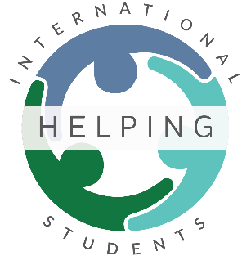
Social Media Coordinator (Marketing)
Location: Hamilton
Department: Communications & Marketing
Reports to: Executive Director
Revised: January 2022

Helping International Students
We are a group of community members that want to help international students thrive in all aspects of life. Our aim is to serve the practical, social, and spiritual needs of Hamilton's international students through various weekly and monthly events as well as providing connections to the services of other like-minded organizations in our city.

The Role
The Social Media Coordinator is responsible for creating and maintaining an online brand presence across a variety of platforms under the Helping International Students Network. The Social Media Coordinator is also responsible for following any conversations relative to the post and to interact with any public responses.

Responsibilities and Duties
- Execute a results-driven social media strategy.
- Develop and curate engaging content for social media platforms.
- Assist in the creation and editing of written, video, and photo content.
- Attend events and produce live social media content.
- Maintain unified brand voice across different social media channels.
- Collaborate with the marketing team to create a social media calendar.
- Monitor social media channels for industry trends.
- Interact with users and respond to social media messages, inquiries, and comments.

Qualifications
- Passion for social media and proficiency with major social media platforms and social media management tools
- Proficiency with video and photo editing tools, digital media formats and social media platforms such as Instagram, Twitter, Facebook to promote events
- Ability to understand historical, current, and future trends in the digital content and social media space
- Strong copywriting and copy-editing skills
- Top-notch oral and verbal communication skills
- Impeccable time management skills with the ability to multitask
- Detail-oriented approach with ability to work under pressure to meet deadlines
Personal Characteristics
The candidate should demonstrate competence in most or all of the following:
- Behave ethically: Understand ethical behaviour and business practices, and ensure that their own behaviour and the behaviour of others is consistent with these standards and aligns with the values of the Helping International Students (HIS)
- Build relationships: Establish and maintain positive working relationships with others, both internally and externally, to achieve the goals of the HIS
- Communicate effectively: Speak, listen and write in a clear, thorough and timely manner using appropriate and effective communication tools and techniques.
- Foster teamwork: Work cooperatively and effectively with others to set goals, resolve problems, and make decisions that enhance organizational effectiveness.
- Lead: Positively influence others to achieve results that are in the best interest of the organization.
- Organize: Set priorities, develop a work schedule, monitor progress towards goals, and track details, data, information and activities.
- Solve Problems: Assess problem situations to identify causes, gather and process relevant information, generate possible solutions, and make recommendations and/or resolve the problem.

